JS Applications Exam – Movies SPA
You are assigned to implement a Single Web Application (SPA) using HTML5, JavaScript, AJAX, REST and JSON with cloud-based backend (Firebase, Backendless or other). Using libraries like Handlebars and Sammy is allowed but is not obligatory. The app keeps users and movies. Guests should be able to register and login. Logged-in users should be able to view all movies, add movie, like movie, see details about a movie and logout. Logged-in users should also be able to edit or delete the movies they have added.

Create a REST Service
Use any cloud-based database and create application to keep your data in the cloud.
Create a collection called movies. Each movie has a name, description, imageUrl, creator and people liked it.

Create Movies Application
HTML and CSS
You have been given the web design of the application as HTML + CSS files.
- Initially all views and forms are shown by the HTML. Your application may hide/show elements by CSS (display: none) or delete/reattach from and to the DOM all unneeded elements, or just display the views it needs to display.
- You may render the views/forms/components with JavaScript or Handlebars.
Important: Don’t change the elements’ class names and ids. Don’t rename form fields/link/ids. You are allowed to add data attributes to any elements. You may modify href attributes of links and add action/method attributes to forms, to allow the use of a routing library.
Client-Side Web Application
Design and implement a client-side front-end app (SPA) for managing movies. Implement the functionality described below.
Navigation Bar (5 Pts)
Navigation links should correctly change the current page (view).
- Clicking on the links in the NavBar should display the view behind the navigation link.
- Your application may hide/show elements by CSS (display: none) or delete/reattach from and to the DOM all unneeded elements, or just display the views it needs to display.
- The Logged-in user navbar should contain the following elements:[Movies] a link to the Home page, the user caption ("Welcome, {email}"), [Logout]. Each link navigates to the named page.
- The guest users navbar should contain the following elements: : [Movies] which is a link to the Home page and [Login], [Register].

Home Page (Guest) (5 Pts)
The initial page (view) should display the guest navigation bar + Guest Home Page + Footer.
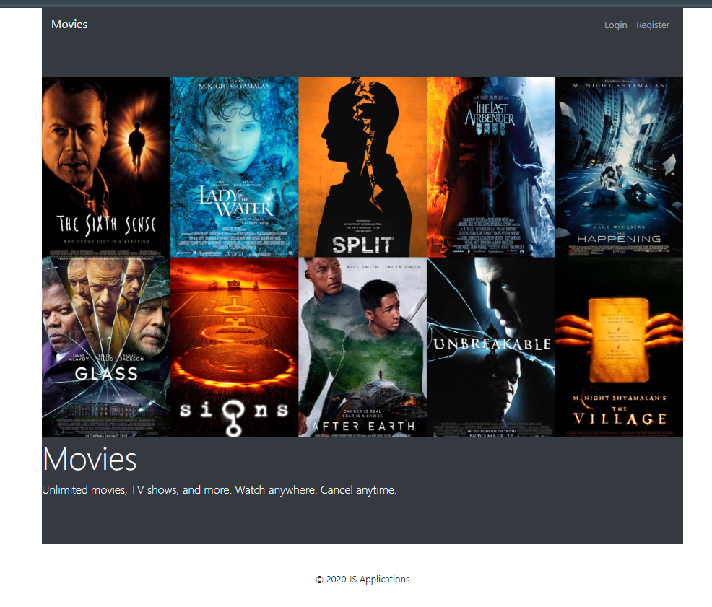
Register User (5 Pts)
By given email and password, the app should register a new user in the system.
- The following validations should be made:
  - The email input must be filled
  - The password should be at least 6 characters long
  - The repeat password should be equal to the password
- After a successful registration, a notification message "Successful registration!" should be displayed and the app should redirect to the home page with the right navbar.
- In case of error (eg. invalid username/password), an appropriate error message should be displayed, and the user should be able to try to register again.
- Keep the user data in the browser's session or local storage.
- After a successful registration redirect to Home page.
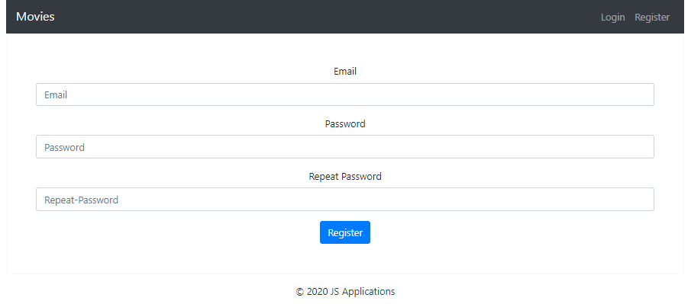
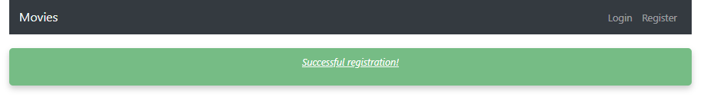
Login User (5 Pts)
By given username and password, the app should login an existing user.
- After a successful login, a notification message "Login successful." should be shown and the user home page should be displayed.
- In case of error, an appropriate error message should be displayed and the user should be able to fill in the login form again.
- Keep the user data in the browser's session or locale storage.
- After a successful login redirect to Home page.
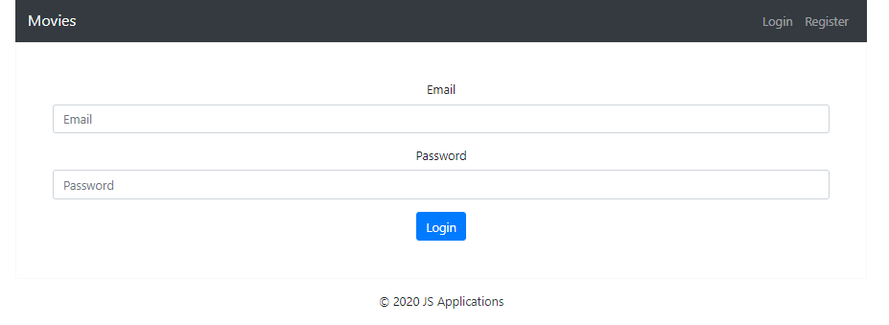
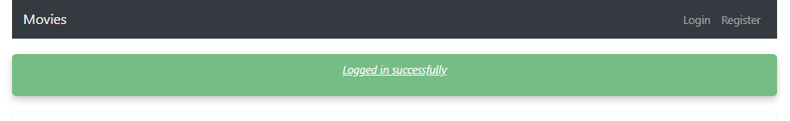
Logout (5 Pts)
Successfully logged in users should be able to logout from the app.
- After a successful logout, a notification message "Successful logout" should be displayed and the anonymous screen should be shown
- The "logout" REST service at the back-end must be called at logout
- All local information in the browser (user session data) about the current user should be deleted
- After a successful logout redirect to Login page.
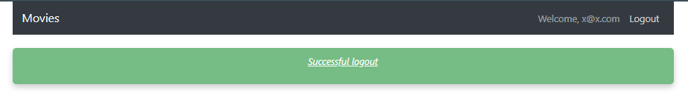
Home Page(Logged in User) (30 Pts)
Successfully logged-in users should be welcomed by the Home page. They should be able to see all added movies:
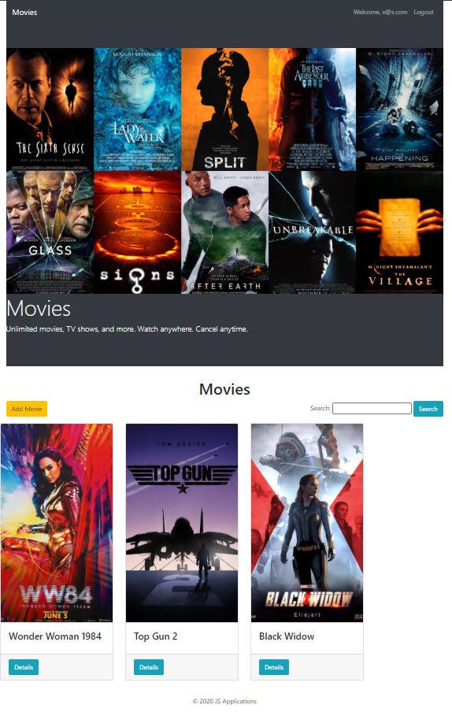
If there are NO such, the following view should be displayed:
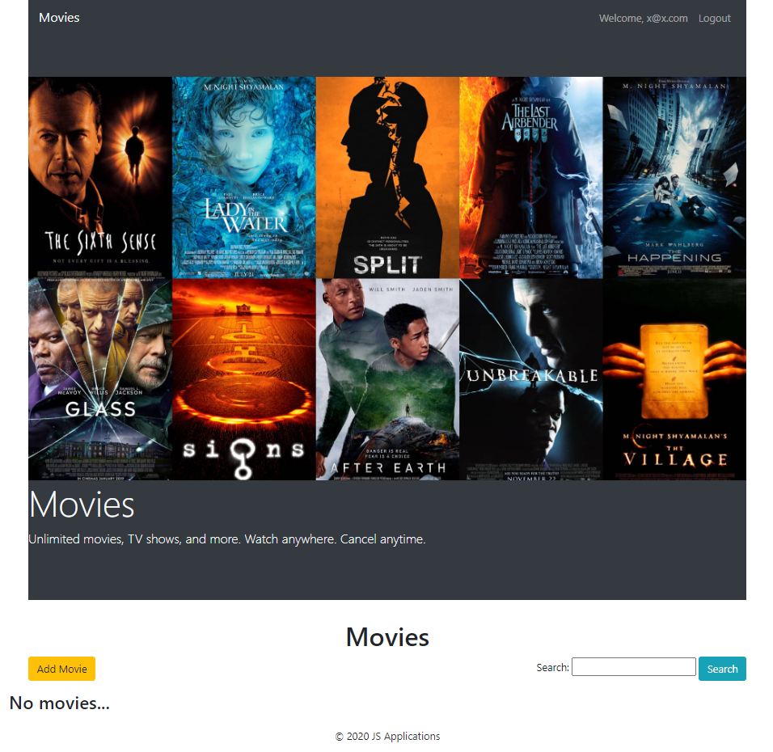
[Add Movie] button should refer to the add movie form
Add Movie(10 Pts)
Logged-in users should be able to add movie.
Clicking the [Add Movie] button in the Home page should display the Add Movie page.
- The form should contain the following validations:
  - The title, description and image shouldn’t be empty.
  - By default, every newly created movie must have additional information:
    - Creator: string representing the current movie creator;
    - People liked: keeping data of users liked the movie;
  - After a successful movie adding, a notification message "Created successfully!" should be displayed and the Home page should be shown.
- The newly added movie should be stored in the database collection "movies".
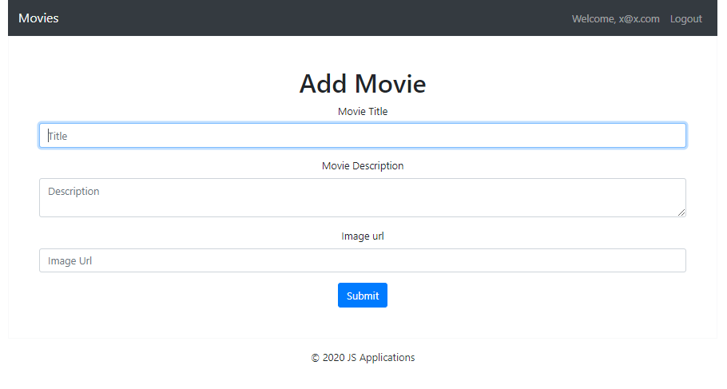
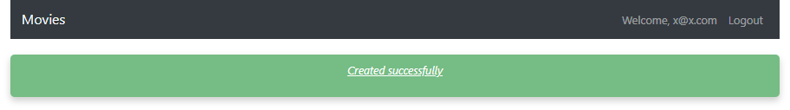
Trying to submit empty feelds shood displаy error:
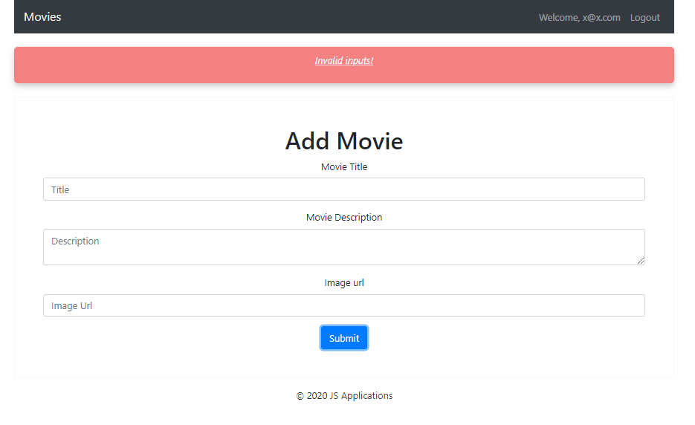
Details (15 Pts)
Logged-in users should be able to view details about movies.
Clicking the [Details] button of a particular movie should display the Movie Details page.
- If the currently logged-in user is the creator of the movie, the [Delete] and [Edit] buttons should be set to visible, otherwise there should be only 1 button [Like].
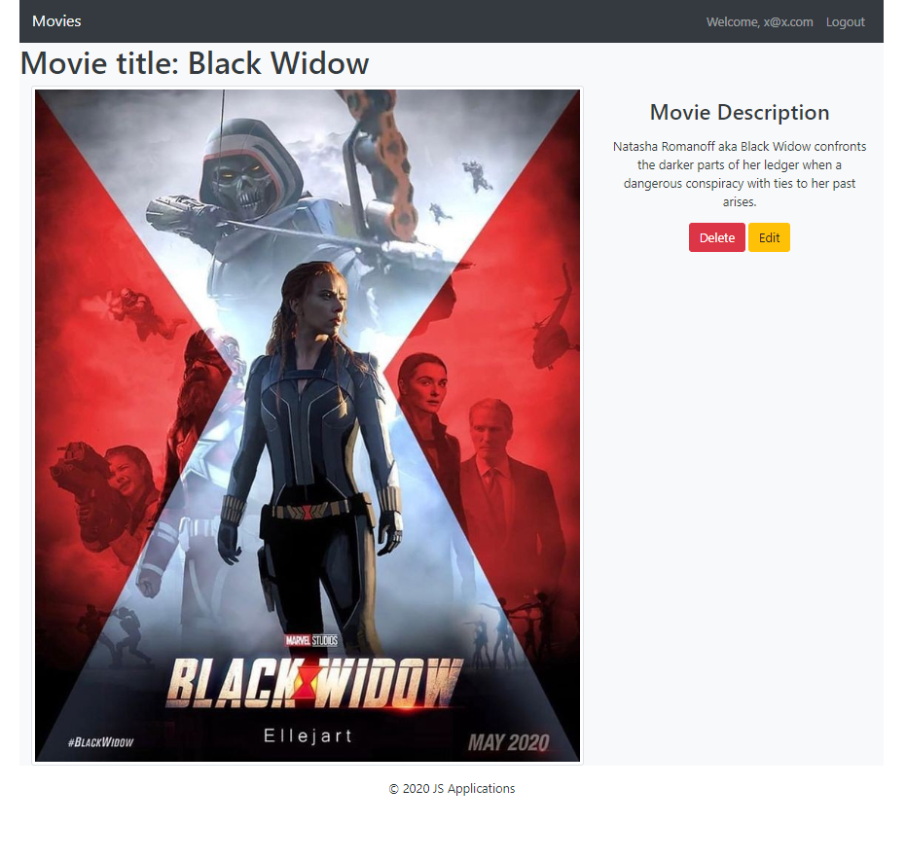
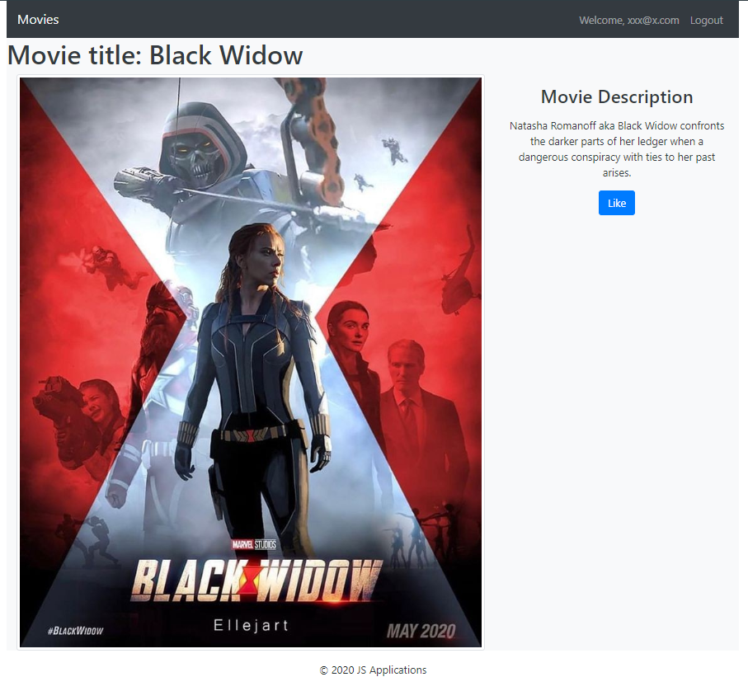
Edit Movie (10 Pts)
Logged-in users should be able to edit movies, added by them.
Clicking the [Edit] button of a particular movie on the Movie Details page should display the Edit Movie page inserting the additional information of the movie in the input feelds:
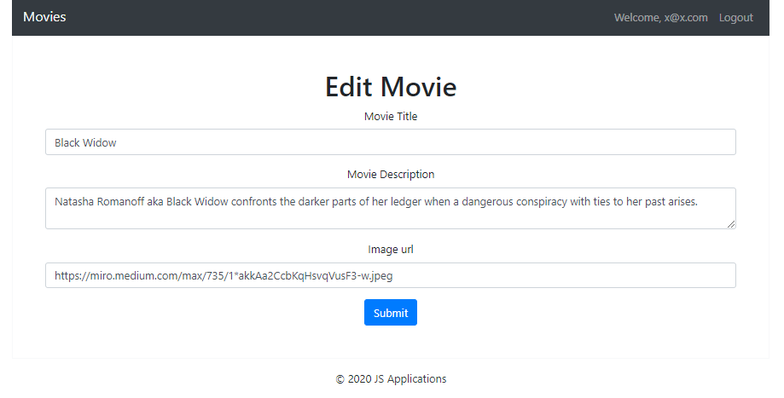

- After a successful edit, a notification message "Eddited successfully" should be displayed, and the user should be redirected to the current movie Details page.
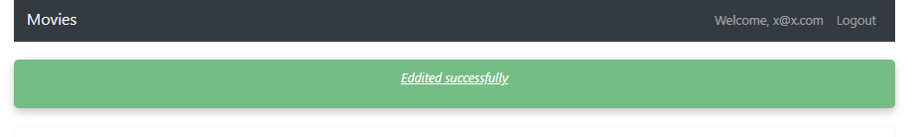
Like Movie (10 Pts)
Logged-in users should be able to like movie, added by other user.
NOTE: A user should NOT be able to like an movie, created by himself.
Clicking the [Like] button of an movie (on the Movie Details page) should add the current user email to the property People liked. After successfully like:
- [Like] button changes to [Liked {number of likes}] span so users can‘t like a movie multiple times.
- Notification message "Liked successfully" should be displayed.
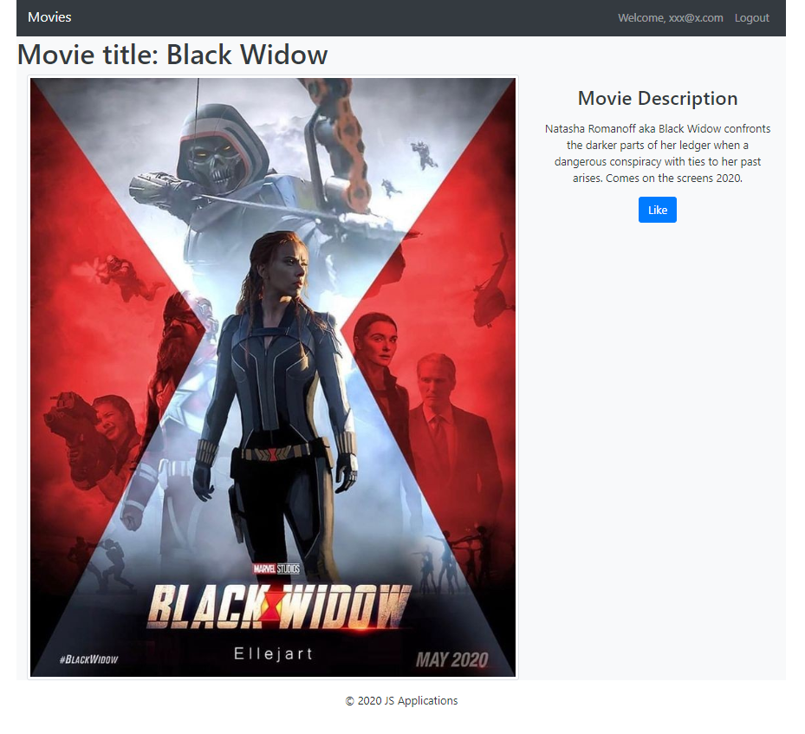
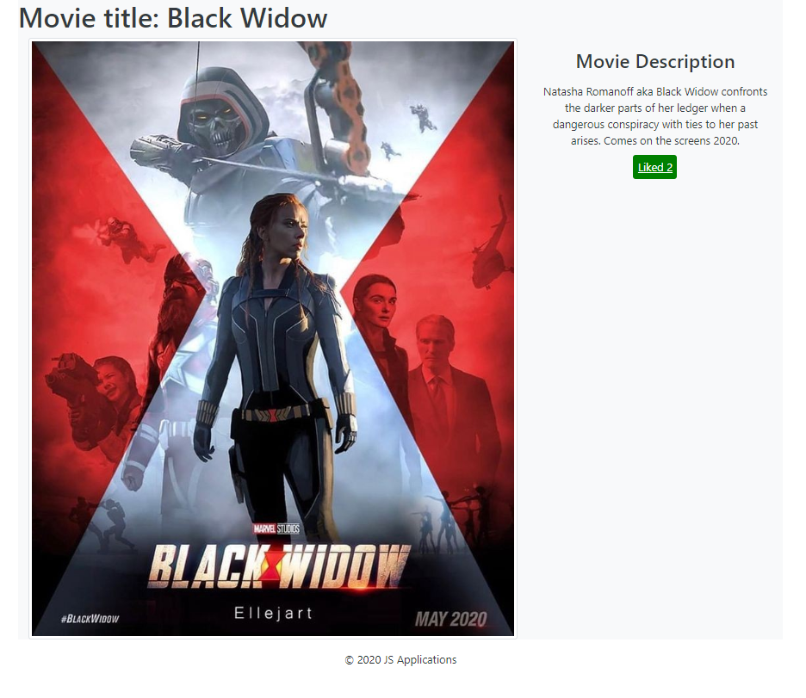
Delete Movie (5 Pts)
Logged-in users should be able to delete their movies.
Clicking the [Delete] button of an movie (on the Movie Details page) should delete the movie.
- After successful movie delete a notification message "Deleted successfully" should be displayed and the Home page should be shown
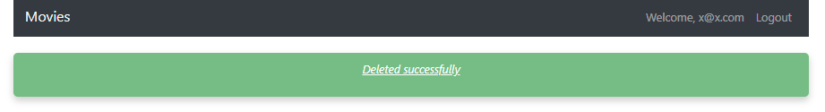
(BONUS) Notifications (5 Pts)
The application should notify the users about the result of their actions.
- In case of a successful action, a notification message (green) should be shown, which disappears automatically after 1 second
- In case of error, an error notification message (red) should be shown, which disappears automatically after 1 second.
- NOTE: You get all the points if all the notifications have the exact content as described in each section above.
(BONUS) Search: (5 Pts)
Registered users, should be able to search in listed movies by entered string into the given search input.

Submitting Your Solution
Exclude the node_modules folder and ZIP your project. Upload the archive to Judge system.
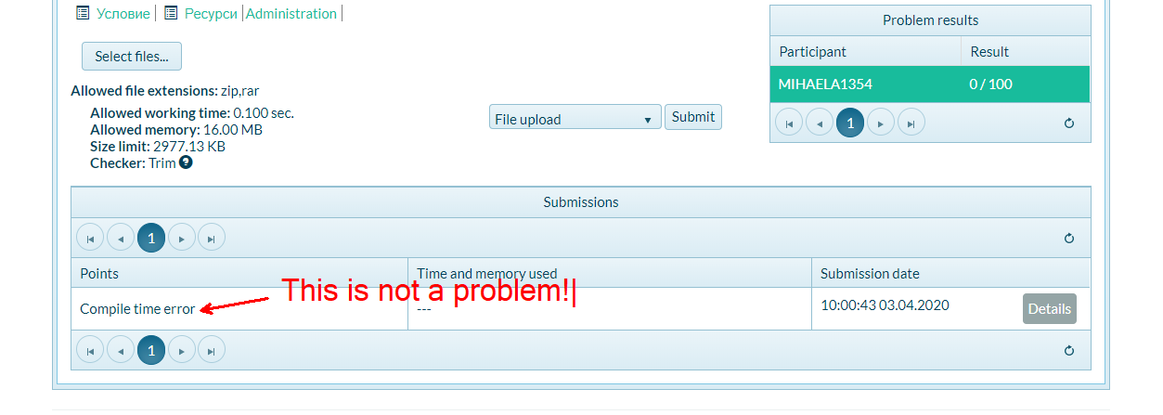

Again: zip the project without the node_modules folder!!!

